Minor ES – Connectivity - Hello World

Authors: Bas Woudstra, Rafał Grasman

# Assignment

Two Xbee modules must communicate with each other.

# Setup

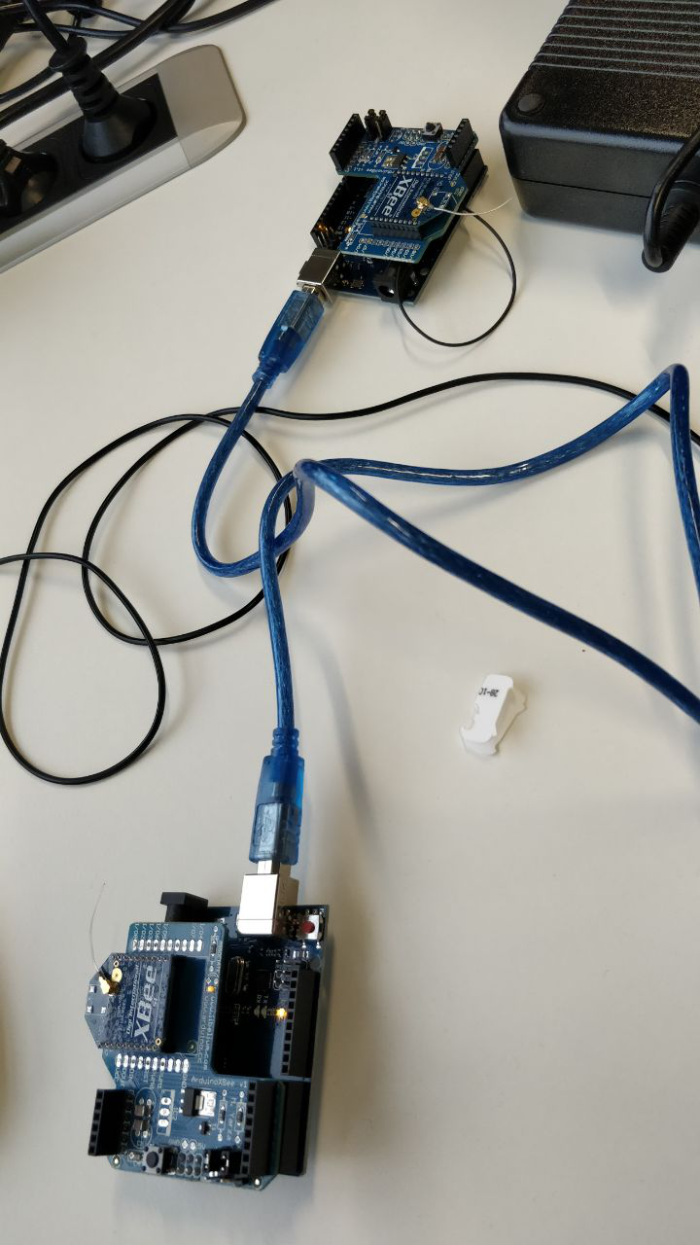

# Code

The echo Arduino is programmed with the ‘echo callbacks’ example (but removed Serial print messages and replaced Serial1 by Serial), see code.zip. The echo Arduino has the Xbee module set to Xbee. The sending Arduino is shorted <ground⬄reset> and the Xbee is set to USB mode. The XBee is controlled from XCTU tool. A transmit request was created then sent using the XCTU terminal.

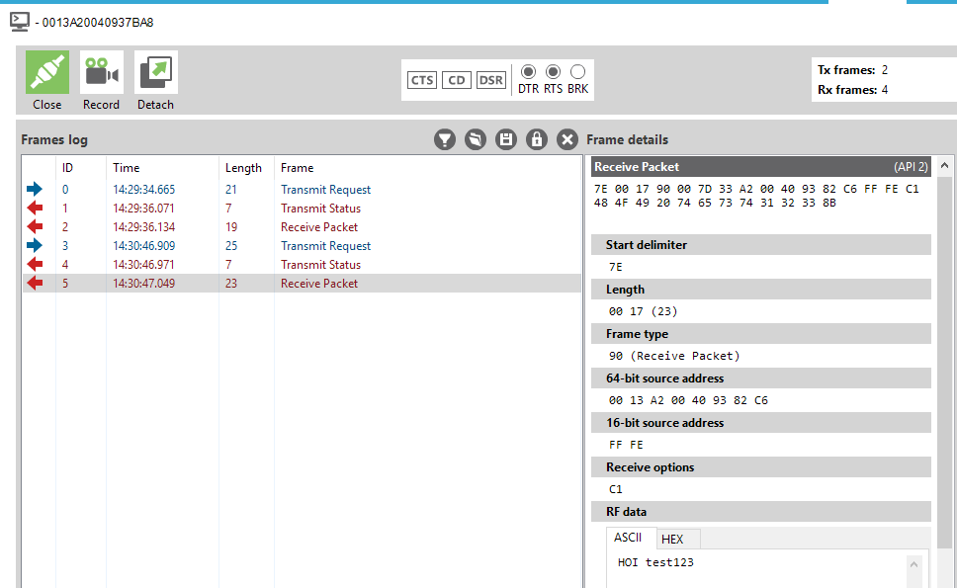

# Results

The API mode allows for targeted communication between two xbees, but requires more setup than simple serial broadcasting (which is very simple to use). The API mode can be used for advanced point to point operations with XCTU.